**OUTPUT OF THE PROGRAM**

**1.PRINTING NAME AND AGE OF THE PERSON USING GETTER METHOD AND CONSTRUCTOR**

1. 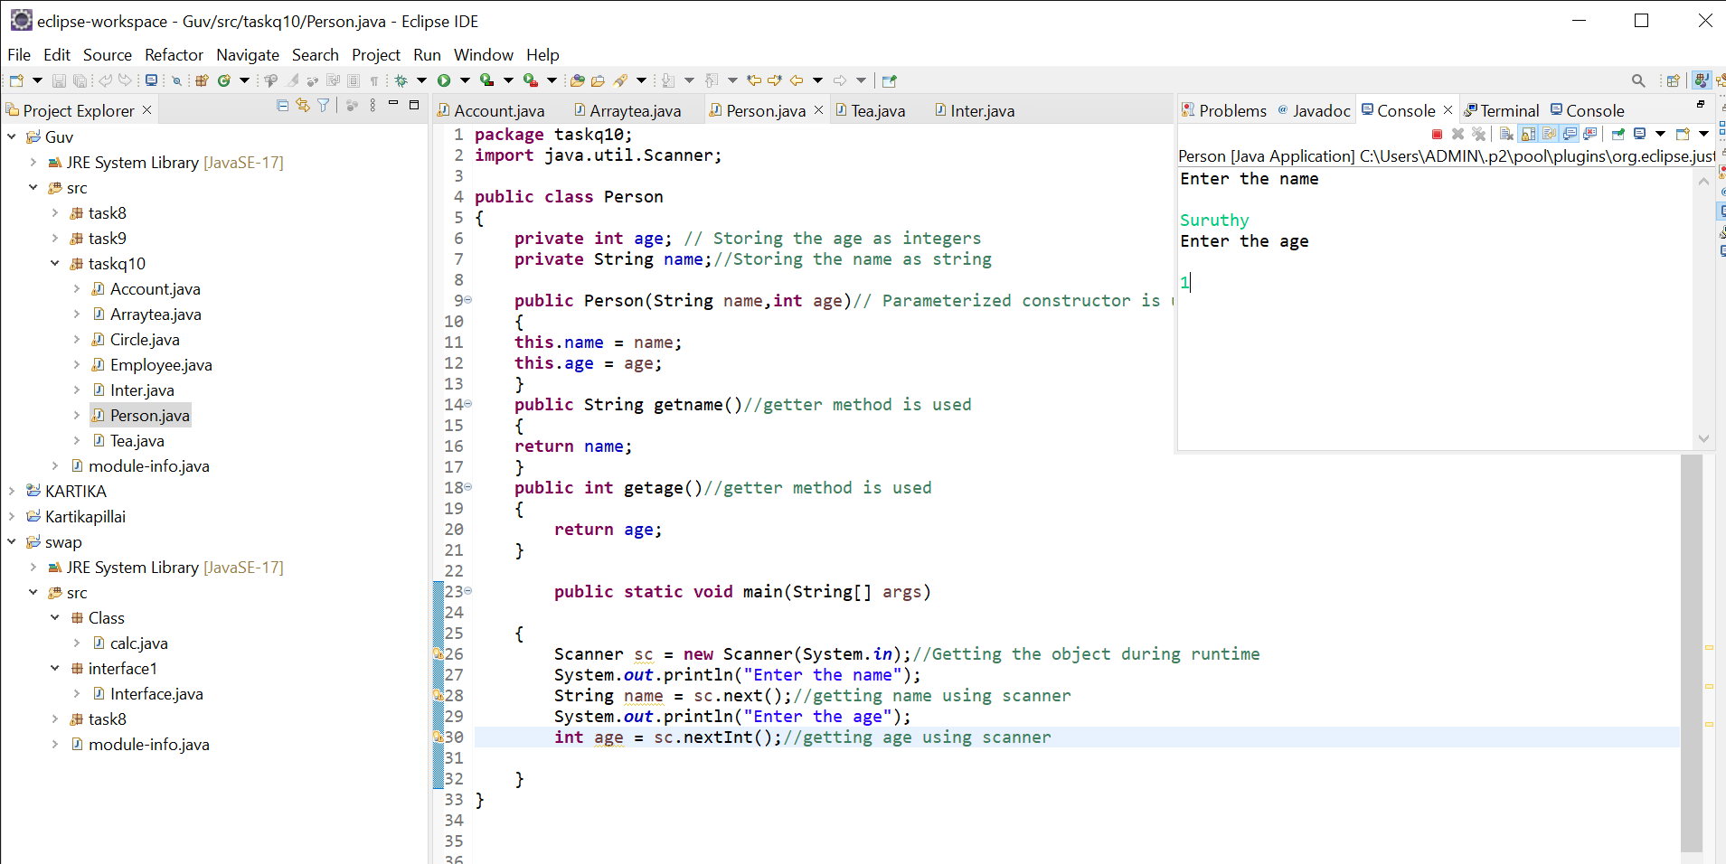

**2.EMPLOYEE DETAILS**

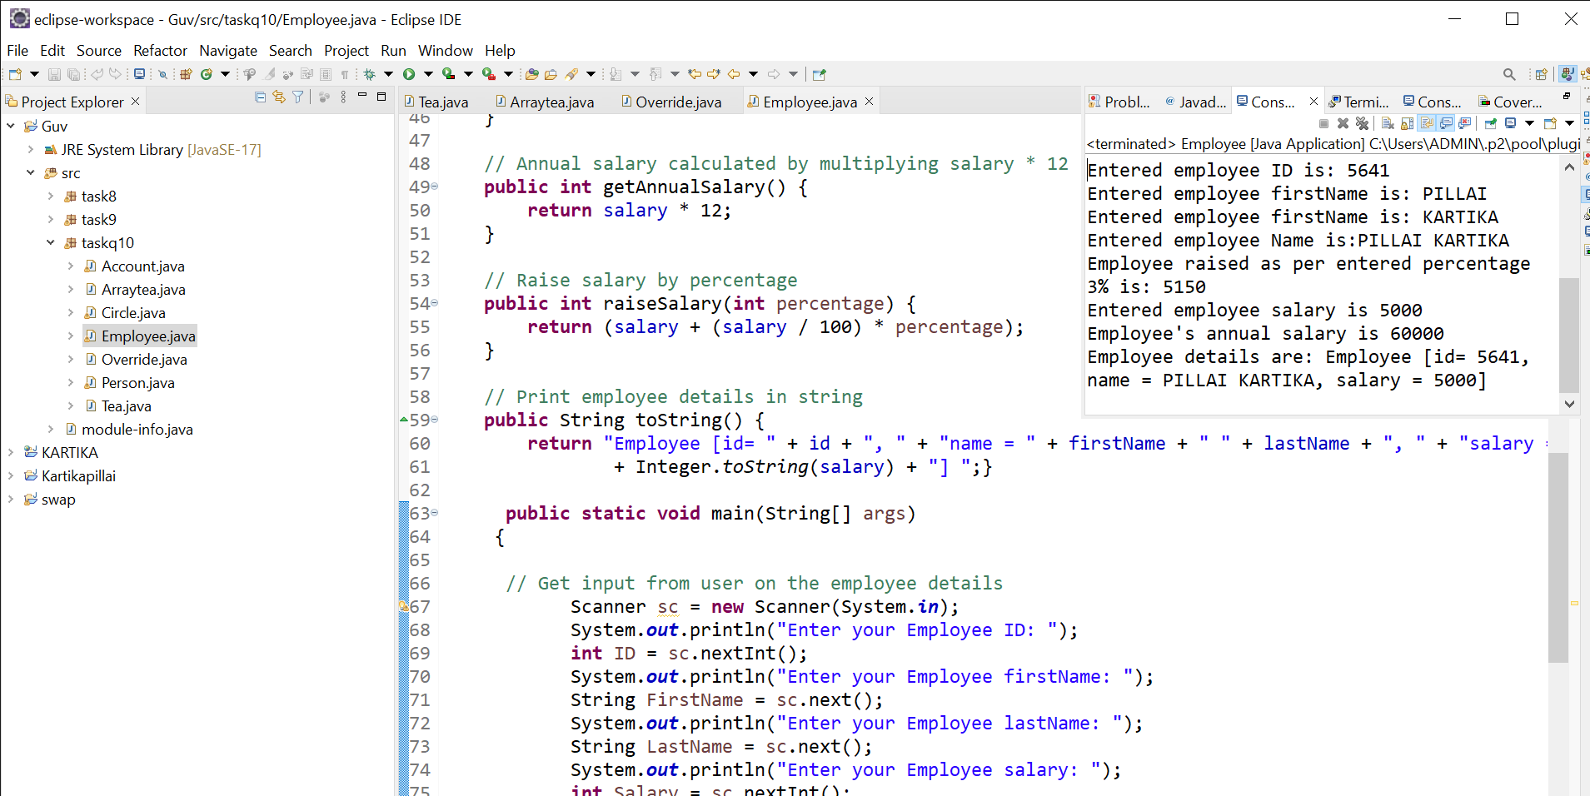

**3.CIRCUMFERENCE OF A CIRCLE**

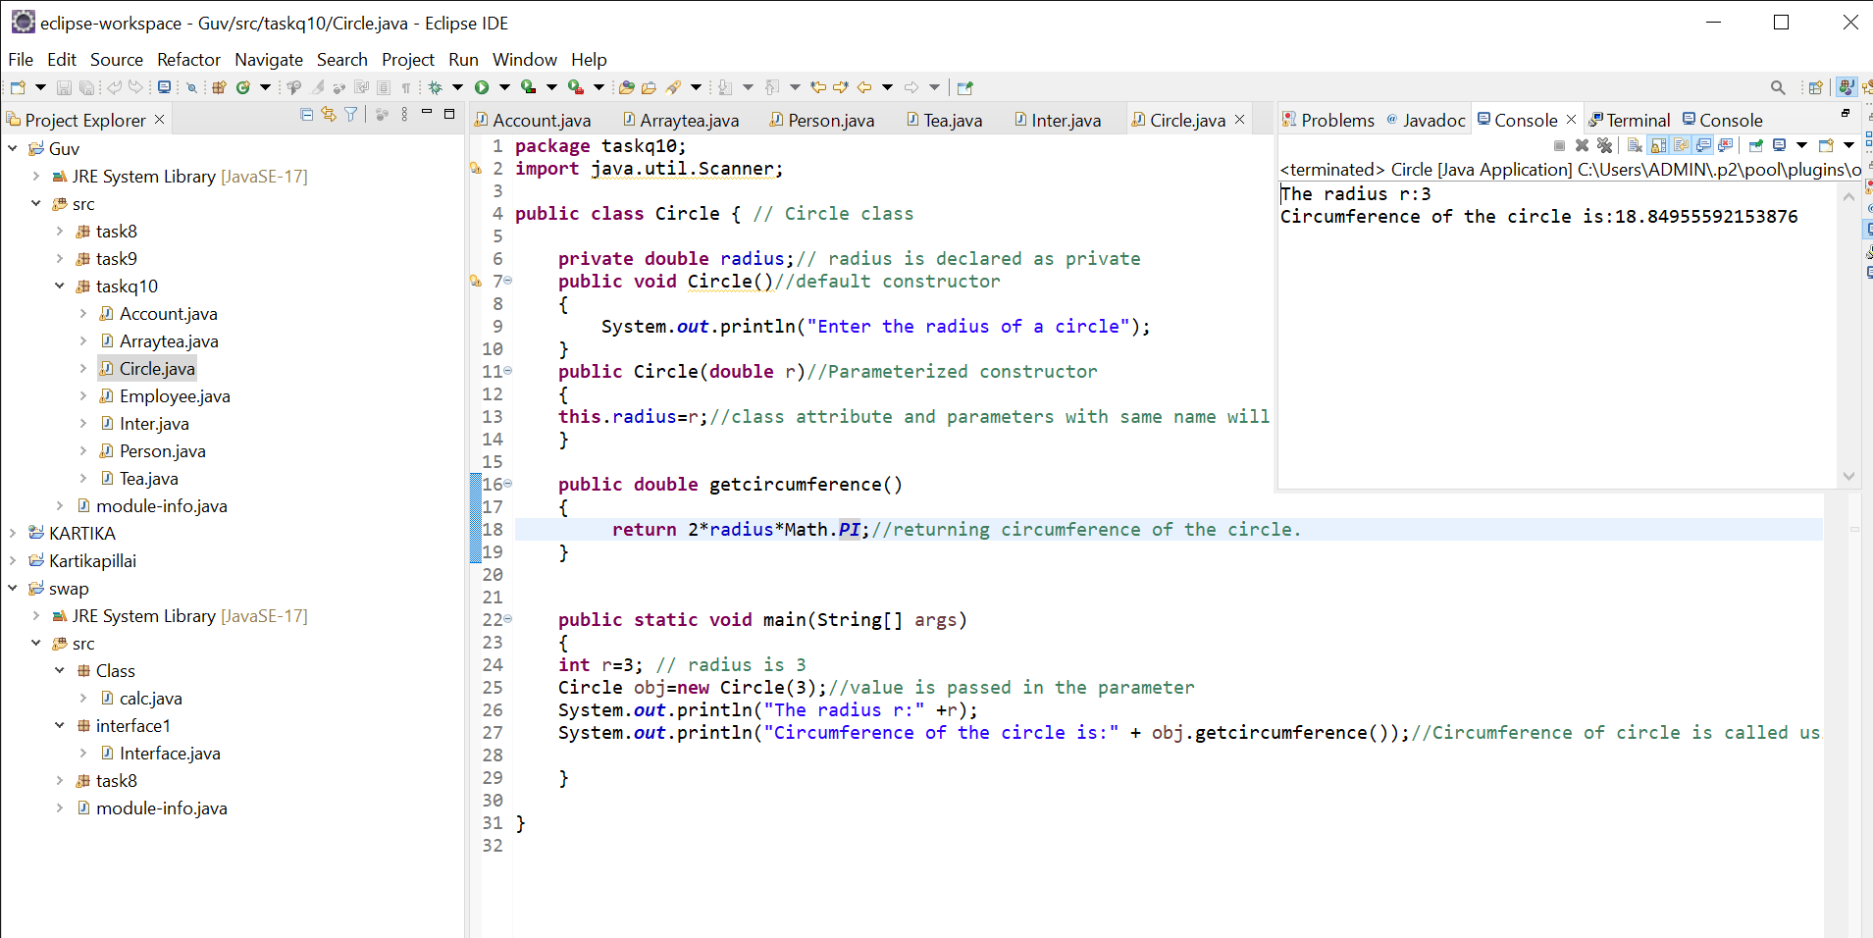

**4.CREATING BANK ACCOUNTING USING WITHDRAW AND DEPOSIT METHOD TO FIND BALANCE:**

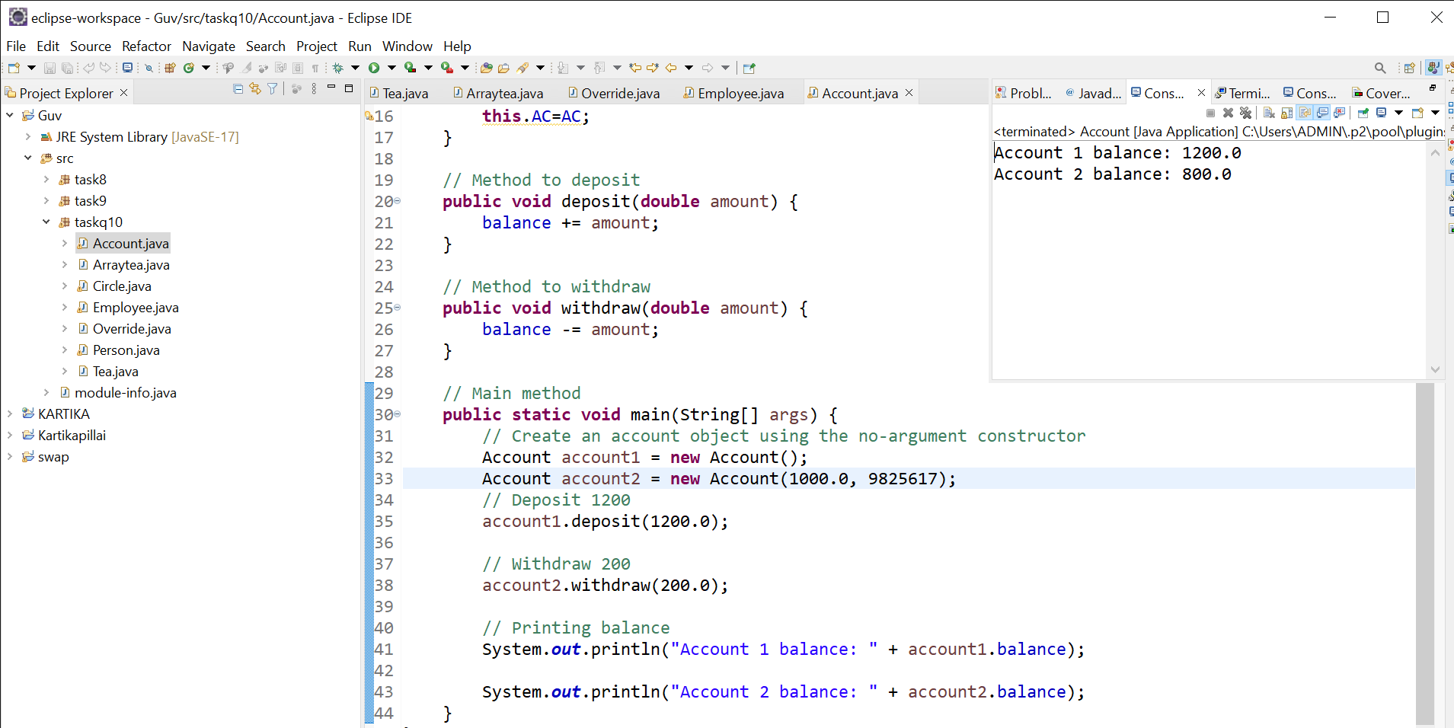

**5.CLASS WITH DIFFERENT METHODS**

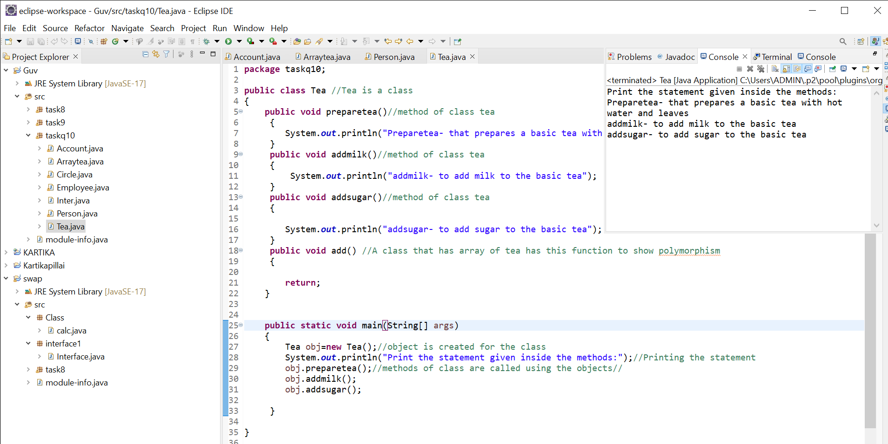

**6.SUBCLASS OF TEA WITH OVERRIDEN METHOD**

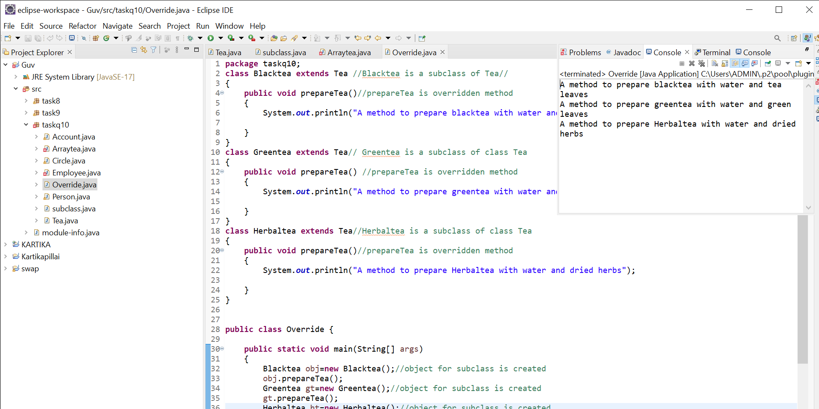

**7.INSTANCES FOR CLASS AND SUBCLASS IS CREATED AND POLYMORPHISM IS IMPLEMENTED**

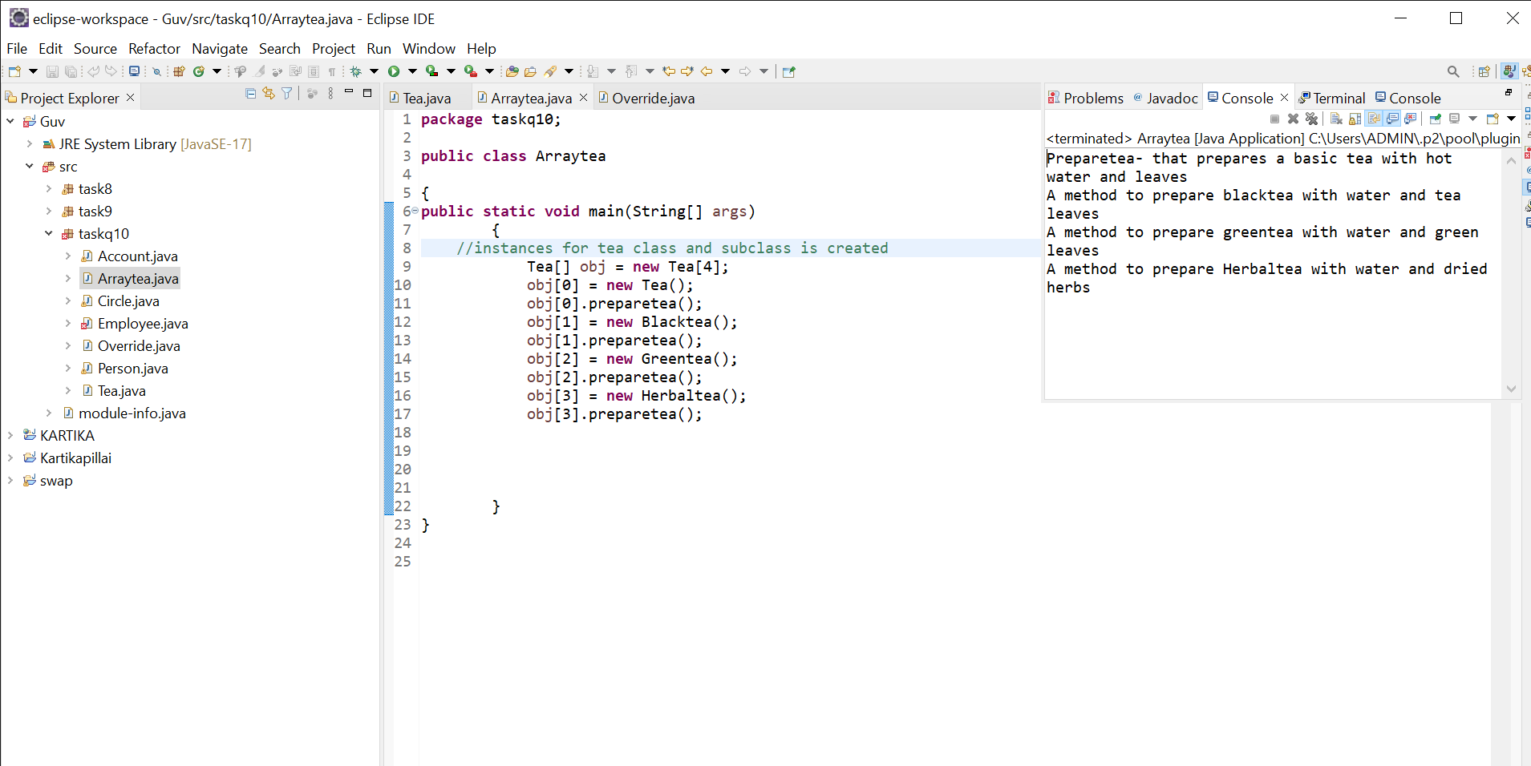

**7.**